EC2 Instance Creation
EC2 Ubuntu Instance Creation

- Region : ap-south-1
- Instance Name : EC2_4Jenkins
- Key Pair : mum_keypair.pem
- Security Key : launch-wizard-1
- Screenshots for reference

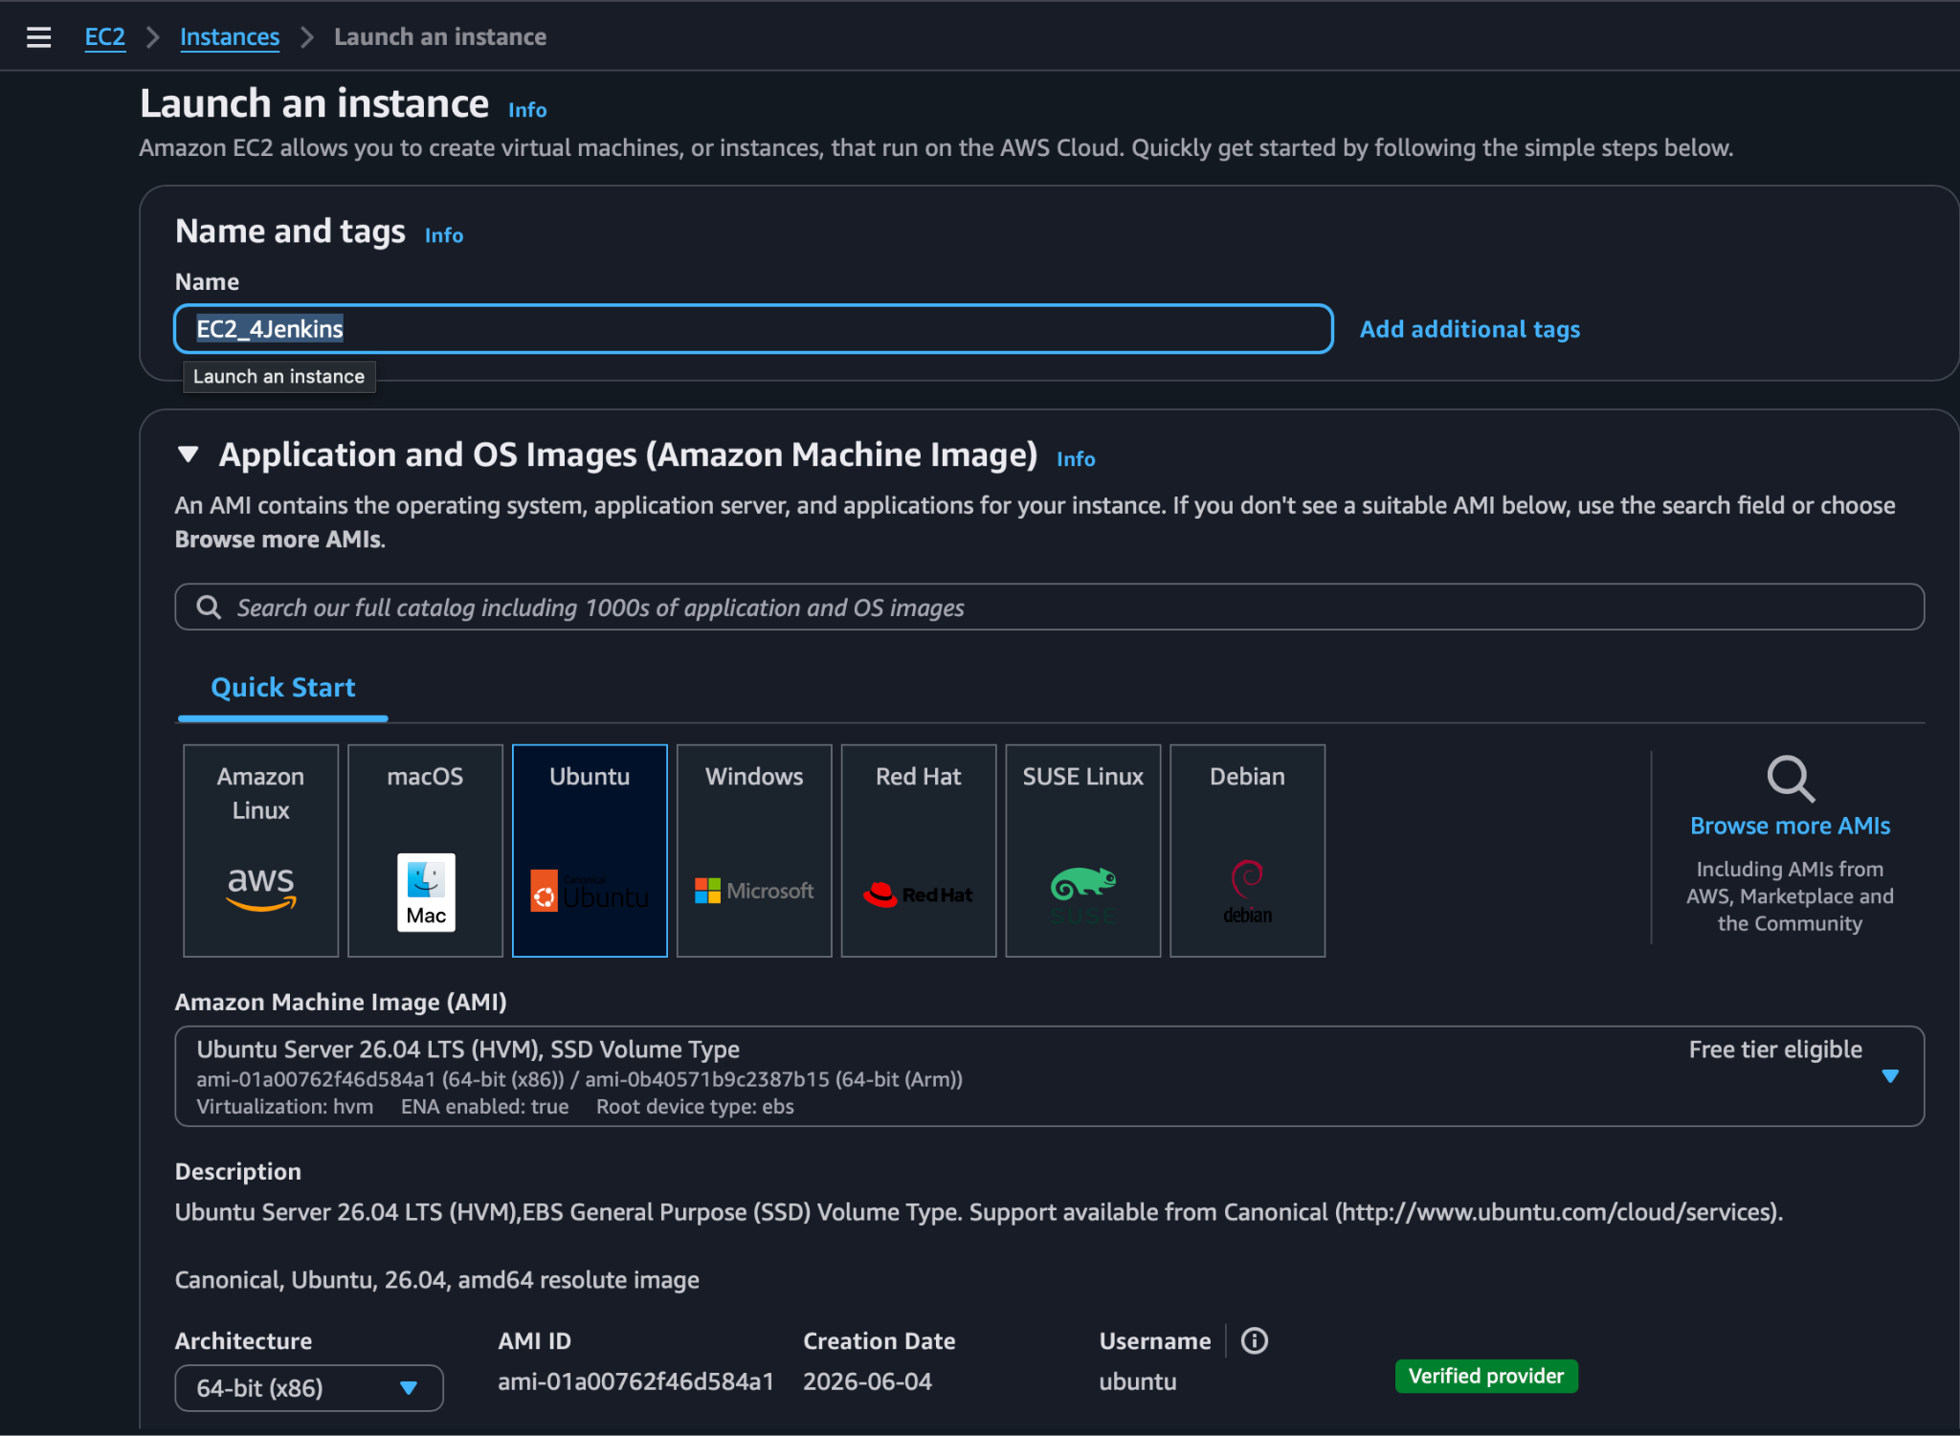

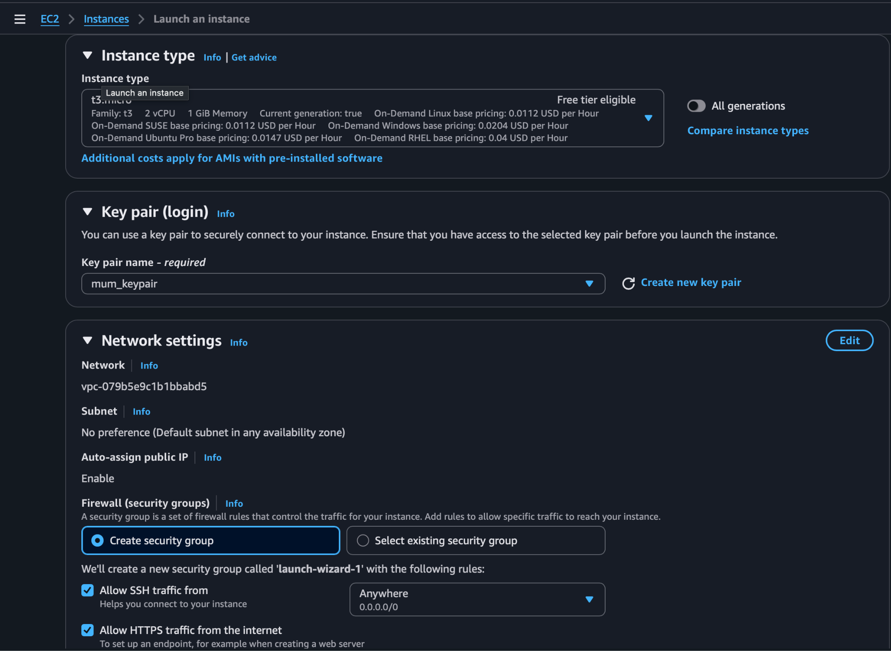

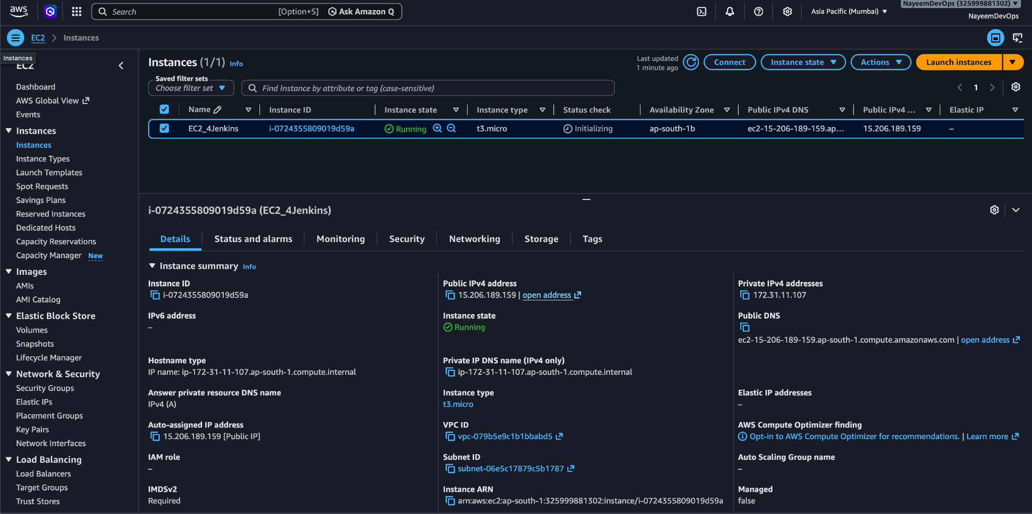
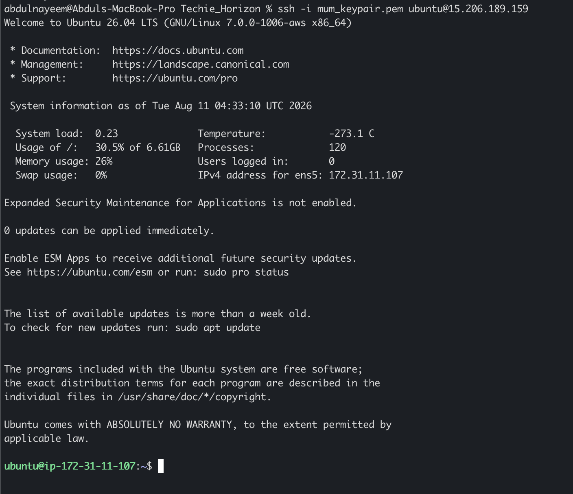

Install Jenkins on EC2
Steps to Download Jenkins on EC2 Ubuntu Instance

- $ sudo apt update
- $ sudo apt install fontconfig openjdk-21-jre -y
- $ java -version
- Install the Jenkins repository key:
  - $ sudo wget -O /etc/apt/keyrings/jenkins-keyring.asc \ https://pkg.jenkins.io/debian-stable/jenkins.io-2026.key
- Install Jenkins
  - $ sudo apt install jenkins -y
- Start Jenkins
  - $ sudo systemctl start jenkins
  - $ sudo systemctl enable jenkins
- Check Status of Jenkins
  - $ sudo systemctl status jenkins

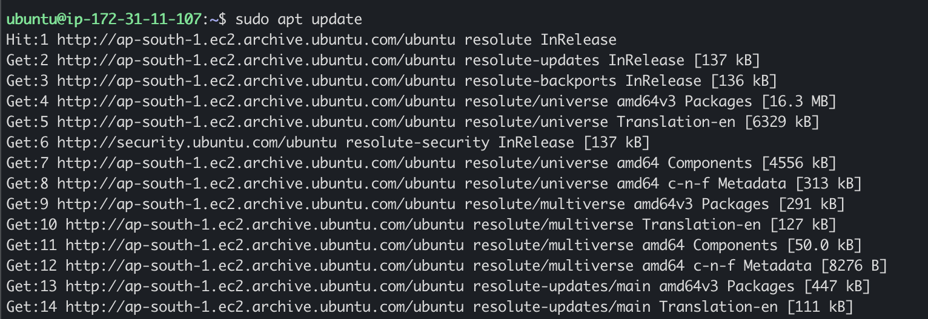

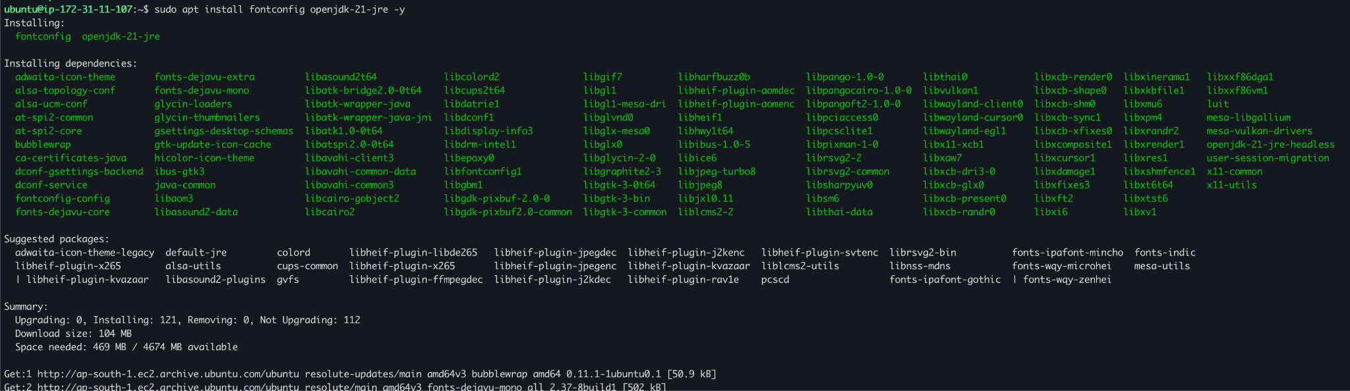

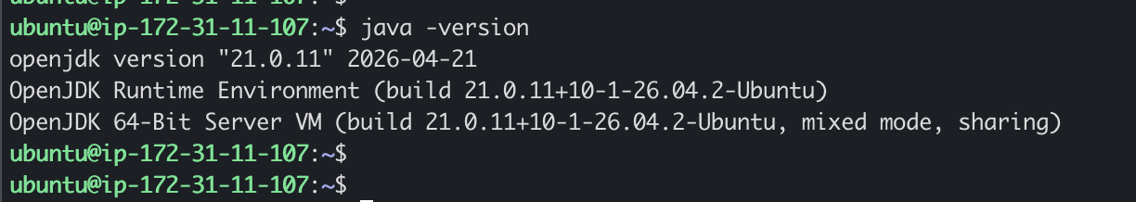
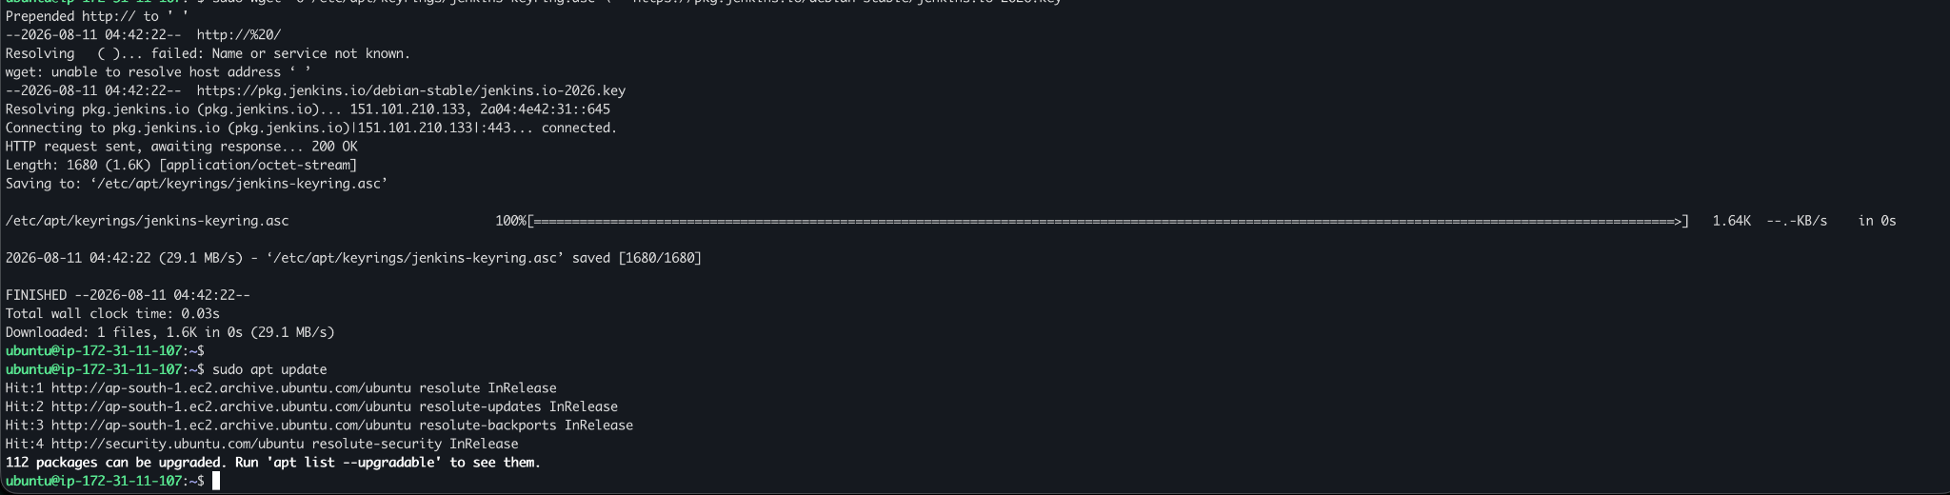
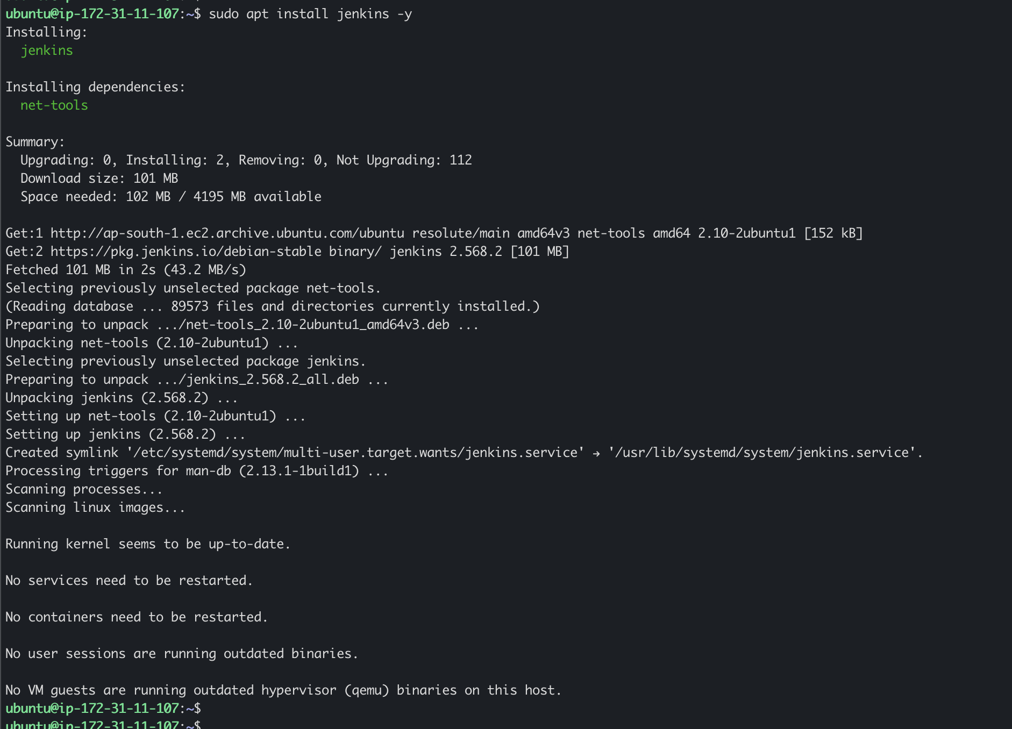
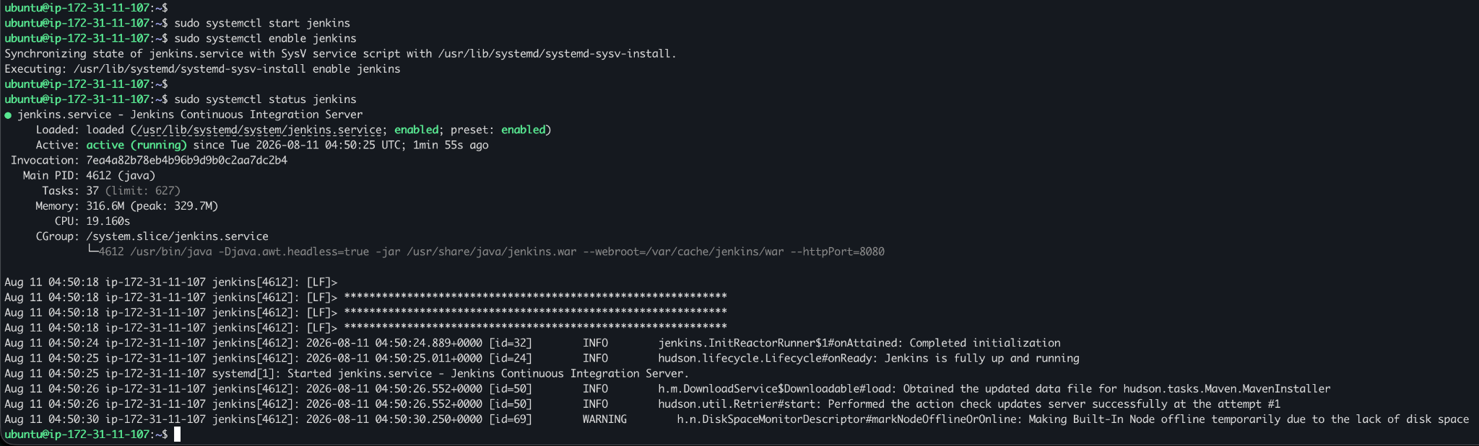

Apache Tomcat on Ubuntu
Setup Apache Tomcat on Ubuntu Virtual Machine

- Got to /tmp directory : $ cd /tmp
- Create a tomcat user
  - sudo useradd -m -U -d /opt/tomcat -s /bin/false tomcat
  - Id tomcat
- Download Tomcat :
  - wget https://dlcdn.apache.org/tomcat/tomcat-11/v11.0.24/bin/apache-tomcat-11.0.24.tar.gz
  - tar -xvzf apache-tomcat-11.0.24.tar.gz
- Provide Tomcat user ownership
  - sudo chown -R tomcat:tomcat /opt/tomcat
- Set executable permissions
  - sudo chmod +x /opt/tomcat/bin/*.sh
- Start the service
  - sudo systemctl start tomcat
  - sudo systemctl enable tomcat
  - sudo systemctl status tomcat
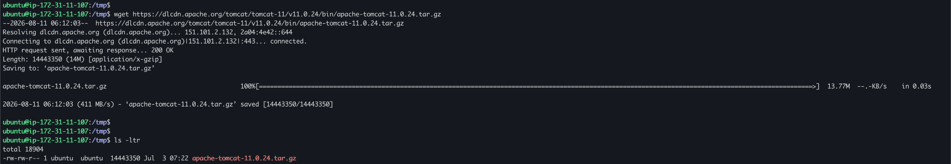

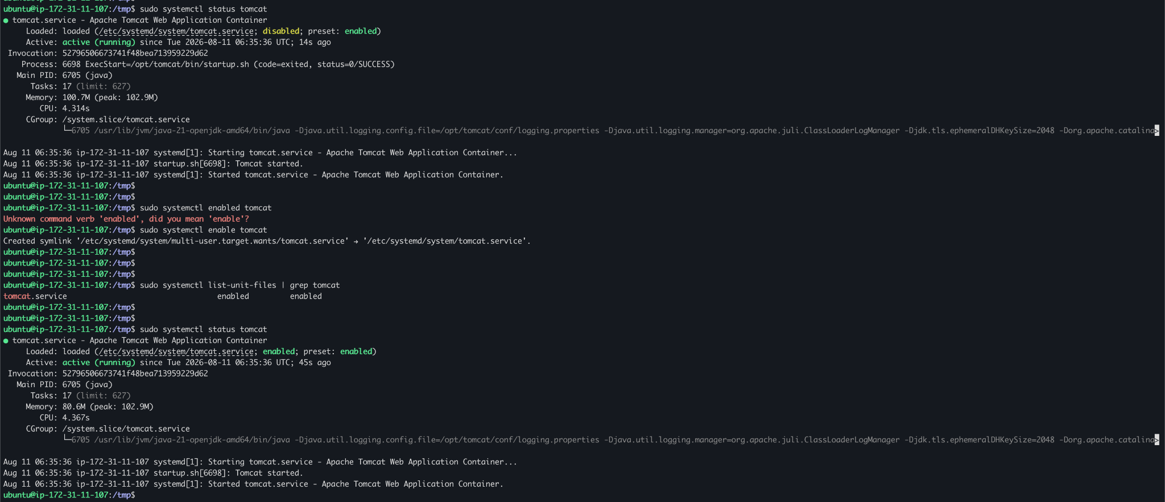

Docker Desktop
